For Immediate Release
November 29, 2018
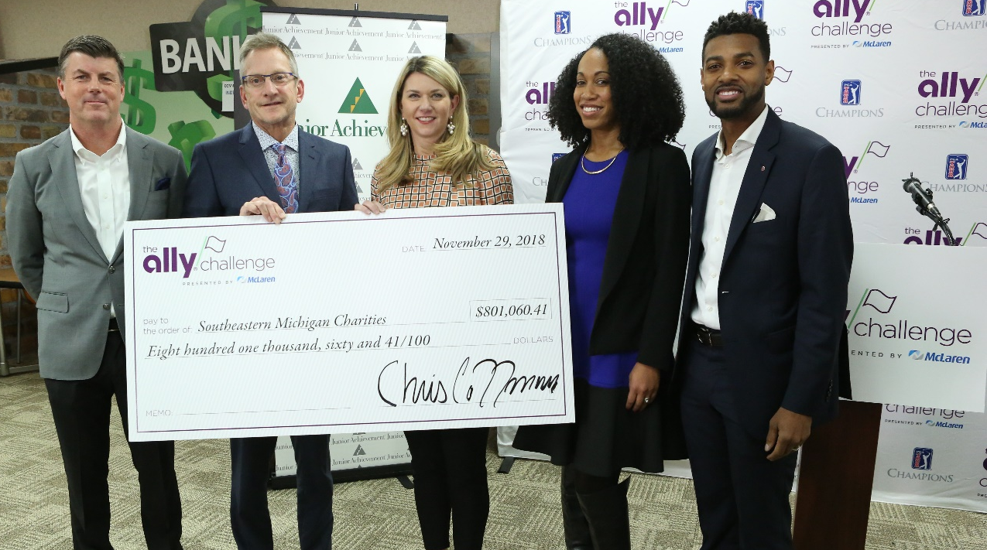

2018 check presentation – pictured left to right: Chris Coffman (HNS Sports Group)
Greg Lane (McLaren Health Care), Ali Summerville (Ally Financial), Kandace Jones (JA), Isaiah Oliver (CFGC)

THE ALLY CHALLENGE PRESENTED BY MCLAREN
ANNOUNCES CHARITABLE DONATION

Inaugural PGA TOUR Champions event generates
more than $800,000 for southeastern Michigan Charities

GRAND BLANC, Mich. – Tournament Officials announced today that the inaugural playing of The Ally Challenge presented by McLaren, concluded September 16, 2018, at Warwick Hills Golf & Country Club, raised $801,060.41 for charitable organizations in southeastern Michigan. The total includes $365,000 for each of the tournament’s primary beneficiaries, Junior Achievement of Southeastern Michigan – serving children in Flint/Genesee County (JA) and Community Foundation of Greater Flint (CFGF).

(more)
Charitable Donation Announced
Page 2
November 29, 2018

“By all accounts the inaugural tournament was a triumph for this community,” said Alison Summerville, business administration executive and head of Corporate Citizenship at Ally. “I’m so happy to present these checks which are the culmination of the hard work of hundreds of people at Ally and in this community to make tournament week a huge success. The legacy of The Ally Challenge presented by McLaren will live on for years to come through the great work of the Community Foundation of Greater Flint and Junior Achievement of Southeastern Michigan.”

“McLaren Health Care is honored to be involved with this worthwhile cause,” said McLaren Health Care Executive Vice President Greg Lane. “It is incredibly rewarding to work with The Ally Challenge presented by McLaren to positively impact the youth of Genesee County. McLaren is committed to making a difference in the communities where we live and work, and we look forward to building on the philanthropic successes of the tournament in 2019 and beyond.”

Junior Achievement of Southeastern Michigan’s mission is to inspire and prepare young people to succeed in a global economy. Junior Achievement is part of the nation’s largest organization dedicated to empowering young people by teaching them the knowledge and skills needed to own their economic success, plan for their future and make beneficial academic and economic choices.

The tournament’s donation will allow Junior Achievement to expedite its five-year growth plan for Genesee County, with emphasis on the expansion of the newly opened JA Finance Park facility on the Flint Campus of Baker College. The JA Finance Park Program will engage middle and high school students in an interactive budgeting simulation that enables them to develop skills to successfully navigate today’s complex economic environment and discover how their decisions can impact tomorrow. Teachers that would like to request JA Programs for their students or individuals interested in volunteering can call Cindy Bazner at (810) 553-4140 or email Meghan Cuneo at mcuneo@jamichigan.org.

“We are grateful to have been selected as one of the charities benefiting from the proceeds of The Ally Challenge presented by McLaren,” said Kandace Jones, President & CEO of Junior Achievement of Southeastern Michigan. “These resources will help inspire and prepare thousands of K-12 students in Flint, and surrounding areas, to succeed in a global economy through their participation in Junior Achievement’s financial literacy and work readiness programming.”

The Community Foundation of Greater Flint serves the common good in Genesee County—building a strong community by engaging people in philanthropy and developing the community’s permanent endowment—now and for generations to come. CFGF helps donors support the causes they care about, today or through their estates. Since 1988 the Community Foundation has granted more than $116 million to nonprofit organizations to build a thriving community. CFGF serves Flint and all of Genesee County including its community funds in Clio, Davison, Fenton, Flushing and Grand Blanc.

The tournament’s donation to the Community Foundation of Greater Flint will support two charitable funds – the Flint Kids Fund and the Flint Promise Fund. The Flint Kids Fund supports the long-term health and development needs of children and families affected by the water crisis with early childhood education, access to healthy food, access to a medical home, and

(more)
Charitable Donation Announced
Page 3
November 29, 2018

family emotional supports. The Flint Promise Fund is a locally-driven initiative designed to offer Flint students more opportunities for post-secondary education through a promise scholarship.

“The Ally Challenge presented by McLaren is the gift that keeps on giving through its investment in Flint’s youth, from birth to high school,” said Isaiah M. Oliver, President and CEO,
Community Foundation of Greater Flint. “This donation is an investment in Flint’s future and a vote of confidence in our children. We are thrilled that the PGA TOUR Champions have a home in Genesee County. Their impact will be long-lasting.”

Additional funds were raised by the tournament through a unique program called Birdies for Charity presented by Ally, a grassroots charity platform that serves as an extension of The Ally Challenge presented by McLaren’s mission to positively impact non-profit organizations in the greater Flint area. A total of 16 qualified Michigan 501(c)(3) charities participated in the program in 2018 and raised $26,721.75 thanks to 876 birdies recorded by PGA TOUR Champions players during competitive rounds at The Ally Challenge presented by McLaren.

“The level of support provided to this tournament from our partners, volunteers, Warwick Hills Golf & Country Club and HNS Sports Group is truly inspiring,” said Andrea Brimmer, chief marketing and public relations officer, Ally. “We are incredibly thankful to all who graciously donate their time to support and help raise funds for charitable organizations in southeastern Michigan, including the tournament’s primary beneficiaries, Junior Achievement of Southeastern Michigan and Community Foundation of Greater Flint.”

Volunteer and program recognition donations round out the tournament’s 2018 giving, totaling $44,338.66 to local charitable organizations, including tournament parking programs and volunteer support in tournament concessions.

“On behalf of HNS Sports Group and our tournament staff, I would like to first thank Ally Financial, McLaren Healthcare and all of our sponsors for their generous support,” said Chis Coffman, The Ally Challenge presented by McLaren tournament director. “When you add in the backing we received from this amazing community, the results we are celebrating today become a reality. The tournament is proud to firmly establish a legacy of giving to youth in southeastern Michigan and is committed to growing its charitable spirit in the years to come.”

The 2019 Ally Challenge presented by McLaren is September 9-15 at renown Warwick Hills Golf and Country Club.

The Ally Challenge presented by McLaren will be one of the premier Regular Season events on PGA TOUR Champions in 2019, which will give way to the fourth-annual Charles Schwab Cup Playoffs – a season-ending, three tournament series used to determine the Tour’s season-long champion.

All three rounds of The Ally Challenge presented by McLaren will be broadcast on Golf Channel.

(more)
Charitable Donation Announced
Page 4
November 29, 2018

For more information about The Ally Challenge, please visit theallychallenge.com. For the latest Ally Challenge news and updates on social media follow the tournament on Twitter and Instagram at @AllyChallenge and on Facebook at Facebook.com/AllyChallenge.

About The Ally Challenge presented by McLaren
The Ally Challenge presented by McLaren is an official event on the PGA TOUR Champions owned and operated by Tournaments for Charity, a Michigan non-profit corporation. This 54-hole stroke play golf tournament features 78 PGA TOUR Champions professionals competing for a $2 million purse at the historic Warwick Hills Golf & Country Club in Grand Blanc, Michigan. The event is designed to showcase the best golf on the PGA TOUR Champions for the enjoyment of spectators and to benefit local charities in the greater Flint area. All three official rounds will be internationally televised on the Golf Channel. For more information, visit www.theallychallenge.com.

For more information about The Ally Challenge presented by McLaren, please visit theallychallenge.com. For the latest Ally Challenge news and updates on social media follow the tournament on Twitter and Instagram at @AllyChallenge and on Facebook at Facebook.com/AllyChallenge.

About Ally Financial Inc.
Ally Financial Inc. (NYSE: ALLY) is a leading digital financial services company with assets of $173.1 billion as of September 30, 2018. As a client-centric company with passionate customer service and innovative financial solutions, Ally is relentlessly focused on "Doing it Right" and being a trusted financial partner for its consumer, commercial, and corporate customers. Ally's award-winning online bank (Ally Bank, Member FDIC and Equal Housing Lender) offers mortgage-lending services and a variety of deposit and other banking products, including CDs, online savings, money market and checking accounts, and IRA products. Ally also promotes the Ally CashBack Credit Card. Additionally, Ally offers securities brokerage and investment advisory services through Ally Invest. Ally remains one of the largest full-service auto finance operations in the country with a complementary auto-focused insurance business, which together serve approximately 18,000 dealer customers and millions of auto consumers. Ally's robust corporate finance business offers capital for equity sponsors and middle-market companies.

For more information and disclosures about Ally, visit https://www.ally.com/#disclosures.

About McLaren Health Care
McLaren Health Care, headquartered in Grand Blanc, Michigan, is a fully integrated health network committed to quality, evidence-based patient care and cost efficiency. The McLaren system includes 12 hospitals, ambulatory surgery centers, imaging centers, a 450-member employed primary care physician network, commercial and Medicaid HMOs covering more than 260,000 lives, home health and hospice providers, retail medical equipment showrooms, pharmacy services, and a wholly owned medical malpractice insurance company. McLaren operates Michigan’s largest network of cancer centers and providers, anchored by the Barbara Ann Karmanos Cancer Institute, one of only 47 National Cancer Institute-designated comprehensive centers in the U.S. McLaren has 24,000 employees and more than 52,000 network providers. Its operations are housed in more than 350 facilities serving the entire Lower Peninsula of the state of Michigan along with a portion of the Upper Peninsula. Learn more at www.mclaren.org.

###

